PERSONAL PROFILE

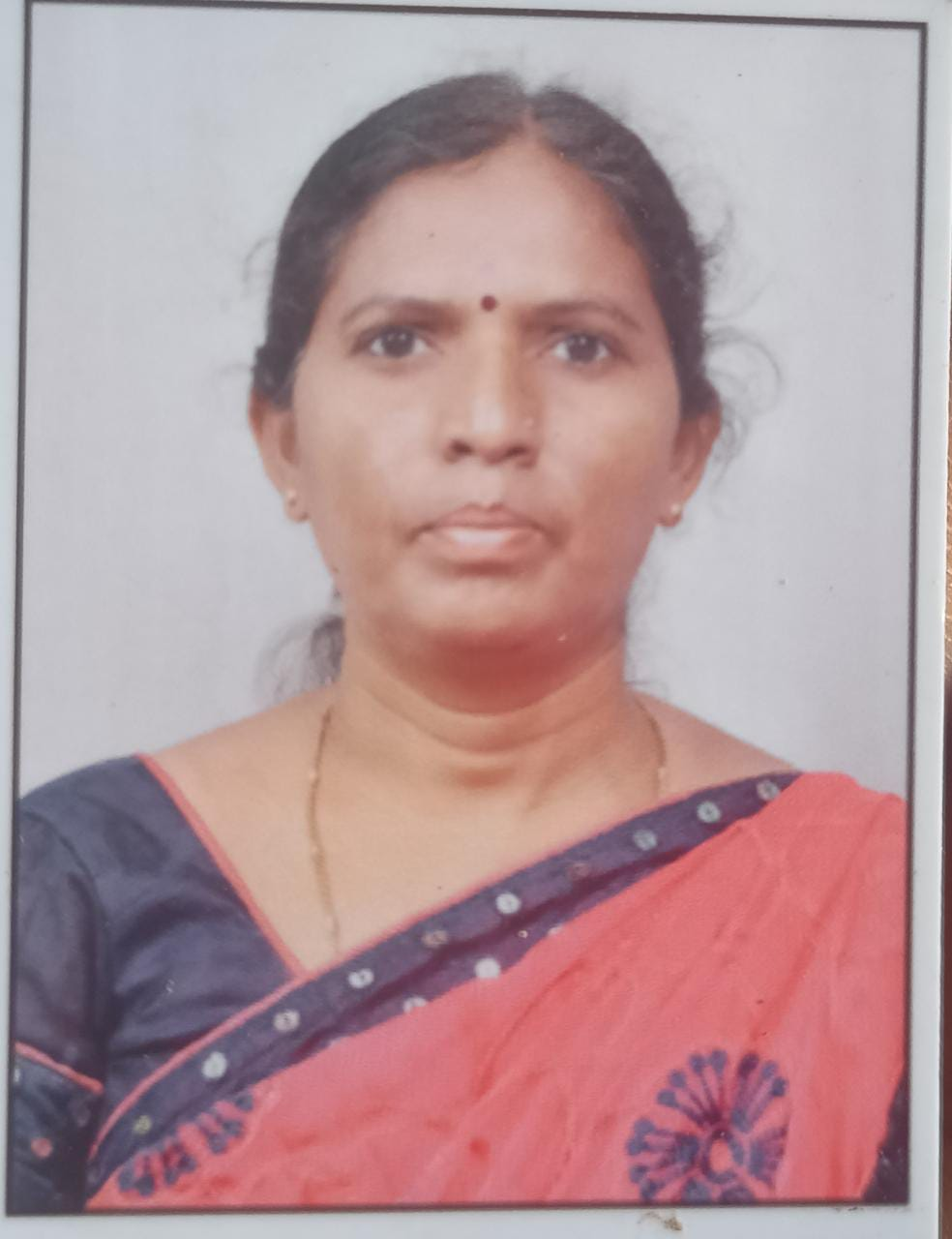
Y VANAJAMMA .,MA., B.Ed., APSET., (Ph.D)
Lecturer in TELUGU
S.K.P Government College,
Guntakal, Anantapur District, Andhra Pradesh,
Mobile: 6305534363
Email: vanajamma2y@gmail.com
_________________________________________________________________________________

- Academic Qualifications and Other details:
Subject : TELUGU
Highest Educational Qualification : MA., B.Ed ., APSET (P.hD)
Aadhar No : 7221 1490 1276
PAN No : AESPV0762L
Employee ID ( for regular staff only ) : NIL
Date of Birth :10/2/ 1979
Social Category : BC-A
Caste : BOYA
Religion : HINDU
Gender : FEMALE
- Date of Joining service as : 03-12-2009
- SVGM G D College : 03-12-2009
- In S.K.P. College, Guntakal : 15-10-2020
- 3. Educational Details:
S.No | Class | Institution Name and Place | From | To | % of marks Division | Board/  University
1 | SSC | ZPP High School vidapanakal |  | 1994 | 50%
2 | Inter I year | GJC URAVAKONDA | 1994 | 1995 | 50%
 | II year | GJC URAVAKONDA | 1996 | 1997 | 50%
 | UG I Year | GDC UKD | 1997 | 1998 | 55.25%
 | II Year | GDC UKD | 1998 | 1999 | 55.25%
 | III Year | GDC UKD | 1999 | 2000 | 55.25%
 | PG Iyear | B Camp kurnol | 2005 | 2006 | 69% | SKU
 | II Year |  | 2007 | 2008 | 69% | SKU
 | B.Ed | St.josaf | 2006 | 2007 | 59% | Anatapur
 | AP SET |  |  | JULY 2012 |  | OU

3.Previous Professional (Teaching) Experience : 11
S.No | Institution | From | To | Designation | No.of Years
1 | SVGM GDC | 3-12-2009 | 5-11-2010 | CTL | 8 M 19 DAYS
2 | GDC(W)KURNOOL | 20-12-2010 | 17-2-2012 | CTL | 10M 27 DAYS
3 | GDC (PRODDtur) | 24-2-2012 | 30-4-13 | CTL | 10M 17 DAYS
4 | Skp GDC | 9-7-2013 | 2-9-2015 | CTL | 19 m
5 | KH GDC | 19-9-2015 | 31-3-2017 | CTL | 15M 09 DAYS
6 | SVBB GDC(KOILKUNTLA) | 25-6-2017 | 5-8-2018 | CTL | 11M 27 DAYS
7 | KTS GDC (RAYADURG) | 8-8-2018 | 15-10-2020 | CTL | 27M 7DAYS
8 | SKP GDC (GTL) | 15-10-2020 |  |  | Till TO DATE

4.Papers and Sections handled ( 2017-18)
S.No | Course | Medium | Title of the Paper
1 | I Bsc/Bcom | T/E | ప్రాచీన కవిత్వం
2 | II Bsc/Bcom | T/E | సాహితీ సౌరభం
3 | III BA (HPT) | T | BHASHA SHASTRA
4 | I st MA | T | BHASHA VIGYAAN –AADHRA BASHA VIKAASAM
5 | II nd MA (TELUGU) | T | 1SAHITY VIARSHA – SOUDARYA SHASTRAM,  2 ENIGLISH FOR COMMUNICATION

National / International/ seminars or Work Shops attended ( add new columns if needed ) :
S.No | National/ International | Place/University | Date | Title of the paper Presented
S.No | DATE | Title of the paper presented | Organized by | International/ National/ State/University level
1 | 8,9-3-2017 | Snataka sthayilo samasa- vibhakti –pratyayala bodhana | Dravidian university | Natonal seminar
2 | 10,11-3-2017 | ఆనాటి స్త్రీలకు విద్య అందని ద్రాక్స పండు | Dravidian university | Natonal seminar
3 | 9,10–2-2017 | Woumen education and economic development | Arts college (M) Anantapur | Natonal seminar
1 | 17 to 21-8-2020 | Faculty development programme | CCE

9 . Extension Lectures / Invited Lectures Delivered :

S.No | Institution | Topic | Date
1 | SSGS AIDED COLLEGE GTL | TELUGU BASHA SANSKRUTI

11. Any other Curricular/Co curricular/Extracurricular Activities involved ( Add Paper )

